**Panel members (Brief Bios)**

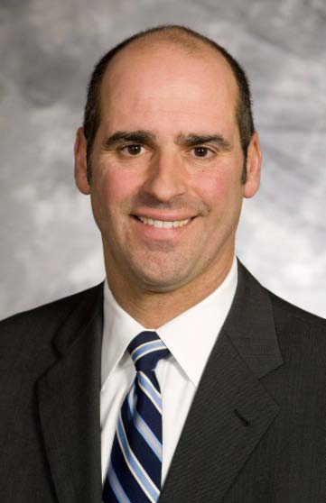**Mr. Charles DiNardo** currently serves as President of Aesculap, Inc. and as member of the Board of Directors of the U.S. holding company B.Braun of America, Inc. B.Braun is a global provider of medical devices, headquartered in Melsungen, Germany and is currently the tenth largest medical device company in the world. The Aesculap Group of Companies provides innovative products and services in the surgical disciplines of general, neuro, spine and orthopaedic surgery. Mr. Charles DiNardo was born in Pittsburgh, Pennsylvania, obtained his undergraduate degree in accounting at John Caroll University and his juris doctorate at Villanova University. Mr. DiNardo practiced corporate securities law for six years at the law firm of Stevens & Lee before joining the B.Braun Group of Companies serving as General Counsel and head of Human Resources. In 2008, Mr. DiNardo assumed his current role as President of the North American operations of Aesculap, Inc. Mr. DiNardo is married with three children.

**Joni Rittler** is the Vice President, Supply Chain Management for The Children’s Hospital of Philadelphia. She has worked in healthcare materials management for over 20 years. She holds a bachelor’s degree in Management of Information Technology from Eastern University and a Master’s Degree in Healthcare Administration from St. Joseph’s University. Joni has held various supply chain management positions in the Philadelphia region as well as serving as the Vice President of Supply Chain Technology for Catholic Health Initiatives, a healthcare system that owns over 70 hospitals across the United States. Her accomplishments include design of business processes, development of shared service centers, optimization of group purchasing organization relationships, distribution and logistics planning, and implementation of Pick-to-Light technology and ERP systems. Through her efforts she has identified and reduced supply expenses achieving more than $125M in a 3-year period for her previous employer and over $60M in a 4-year period at CHOP. Joni’s current role at CHOP is to provide vision and leadership for an integrated supply chain across the organization. She works to ensure the purchase of the highest quality materials/services at the best cost, to establish standards of excellence, to design systems and metrics to measure both financial and operational performance, and to develop strategic internal and external alliances. She serves as the executive sponsor for the All Abilities Resource Group, an employee team working to raise awareness and provide education related to employment of people with disabilities. She serves on the Supply Executive Council for Novation and the Supply Chain Leadership team for Children’s Hospital Association. She is an active member of Strategic Marketplace Initiatives, an industry group that sponsors the development of tools and practices to support the healthcare supply chain industry.

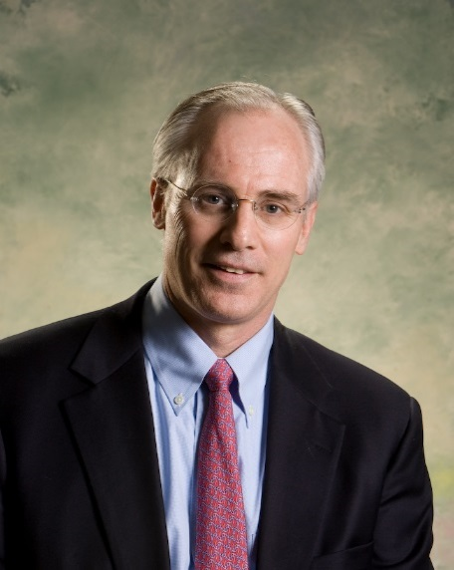**Jeff Voigt** is the principal of Medical Device Consultants of Ridgewood, a firm dedicated to ensuring appropriate coverage and payment policies for medical technology companies (mainly earlier stage) and insurers. His expertise also includes healthcare analytics, cost-effectiveness analysis, evidence development, and assessments. These are in turn are used to assist policy makers in developing coverage for technologies that provide value. Jeff has published numerous articles on evidence assessments, cost-effectiveness, and health policy commentary in several peer reviewed journals. In addition, Jeff has established Medicare new technology add on payments, Medicare pass through codes, written coverage policies, and established numerous CPT level 1 and level 3 codes for the firms he has worked with. He has worked in the medical technology industry for over 28 years, in marketing, sales, and business development positions of increasing responsibility. He has helped build several companies from the ground floor to very profitable organizations – all of which were ultimately sold to larger organizations. His education includes: a bachelor’s degree from University Vermont, a Master of Public Health from Columbia University, and a Master of Business Administration from the Wharton School, class of 1985. Jeff recently served as President of the Wharton Healthcare Management Alumni Association (WHCMAA) and was on the WHCMAA board from 2010-2015. He is still active in the WHCMAA and with volunteer positions in the town of Ridgewood, NJ.

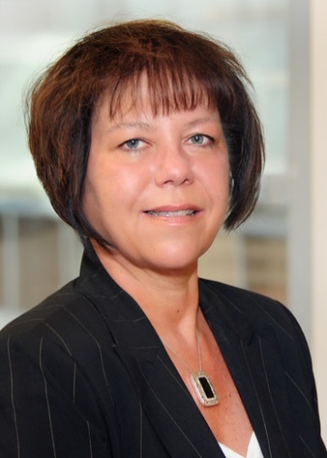**Patricia Kinn**, R.N. , BSN, Senior Director Medical & Claim Payment Policy, Independence Blue Cross. As Senior Director of Medical & Claim Payment Policy, Patty is responsible for the Development and Maintenance of all Commercial and Medicare Advantage Medical and Claim Payment Policies, Policy Enforcement, Clinical Coding and Specialty Pharmacy Services covered under the Medical Benefit. Patty has held several leadership positions within the Independence Family of Companies during 25 + year tenure. Independence is the largest health insurer and managed care organization in the Philadelphia region. Her areas of Expertise include those accountabilities defined as part of her current position as well as Network Development and Provider Contracting, Health Plan Operations, Clinical Vendor Relationships and Utilization Management. Additionally Patty actively participates on various local and National Health Plan initiatives with the Blue Cross Blue Shield Association (BCBSA), America’s Health Insurance Plans (AHIP) as well as a multitude of Focus Groups. Patty received her B.S. in Nursing from Duquesne University in Pittsburgh and is also a graduate of Leadership Philadelphia.